PPT script

**Script:-**

* Slide 10: Simple Swaps: Healthy Alternatives & Mindful Eating

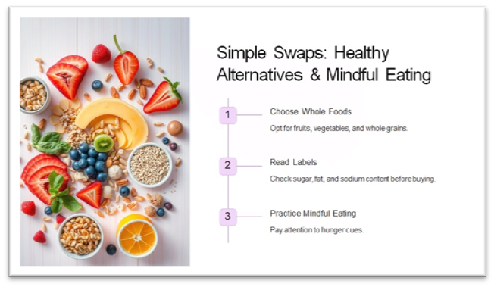

"Hi everyone! Let's start by talking about something super simple we can all do every day — making better food choices without giving up taste.

This slide is about simple swaps and mindful eating. Instead of eating packaged or junk food, try choosing whole foods — like fruits, vegetables, nuts, and whole grains. They give our body real energy and help us feel better.

Next, read labels when you buy snacks. It might sound boring, but checking for sugar, salt, and fat content can really make a difference. Too much of those can harm our health over time.

Lastly, practice mindful eating. That means paying attention to your hunger. Are you actually hungry, or just bored? Eating slowly and not while watching TV helps too. Your body will thank you!"

* Slide 11: The Well-Balanced Plate & Benefits of a Balanced Diet

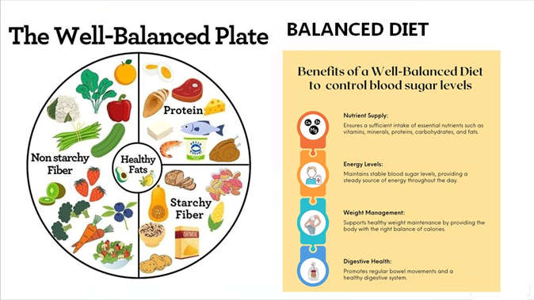

"Now let’s look at what a healthy, balanced meal should look like.

On the left side, you can see the Well-Balanced Plate. It's divided into parts:

The biggest part is for non-starchy fiber, like leafy greens and colorful veggies.

Then we have protein — this can be eggs, chicken, fish, or plant-based like beans.

We also need starchy fiber like oats, potatoes, or whole grains for energy.

And finally, healthy fats — things like avocado, nuts, and olive oil.

On the right, you can see the benefits of eating this way:

It gives our body the right nutrients to grow strong and stay healthy.

It keeps our energy levels stable throughout the day.

It helps with weight management and keeps our digestive system working well.

Eating like this isn't a diet — it’s a way of taking care of yourself every day."

* Slide 12: Supporting Evidence

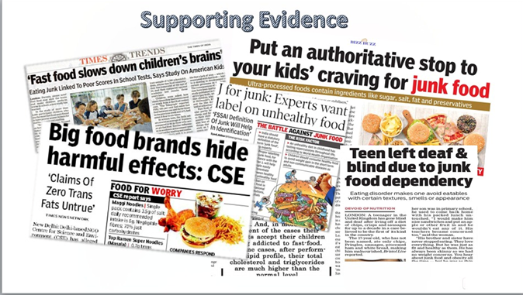

"You might be wondering — 'Is junk food really that bad?' Well, yes — and there’s proof.

This slide shows real newspaper headlines. Some say junk food slows down children’s brains, or how it causes serious health problems like obesity and heart issues.

Some kids even get so used to junk food that they can't eat anything else — which can lead to dangerous deficiencies and poor school performance.

Also, big food brands often hide harmful facts about what’s in their products. That’s why it’s so important to be aware of what we eat.

So, next time you're hungry, think twice before picking up chips or soda. You can choose something tasty and healthy instead!"